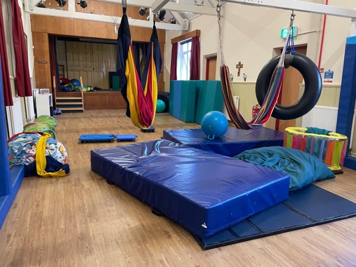
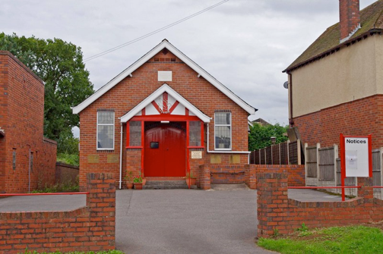
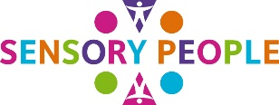

Sensory People
Funding Appeal 2026
Registered Charity No: 1164806
www.sensory-people.co.uk

Sensory People Charity celebrated ten years of providing clinically specialist and evidence based (Ayres) Sensory Integration Therapy (ASIT) in December 2025.
We provide early-intervention support for children and young people with sensory processing challenges, many of whom have diagnoses such as autism, ADHD or dyspraxia. We currently see between 45 and 50 families regularly in ASIT and/ or COOL KIDS sessions. Additionally, we run a regular Charity Information evening and see families for assessment and/ or support. We expect to be able to double that number when our new facilities are ready for use and we have staff in post.
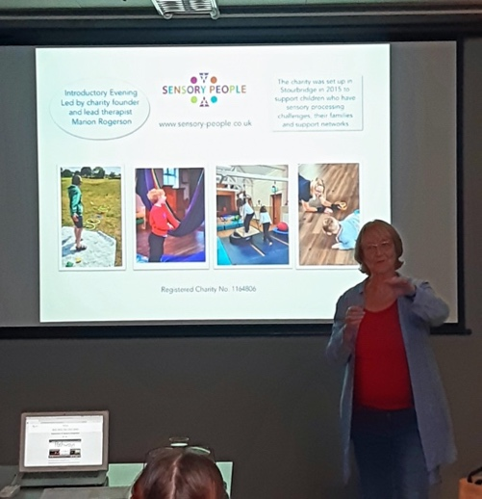
Demand for our services has grown substantially in recent years.
It is often, when they are at a place of last resort, and in considerable distress, that families find us. We provide children described as “suicidal” with immediate/ priority access to our services. Our early intervention and evidence-based services, improve emotional wellbeing, facilitate developmental progress and future independence.

Left: Charity Information Session with Chair/Founder Marion Rogerson

Request & Appeal for £60K
to complete the mezzanine level of our specialist
Sensory Integration Therapy Centre

Sensory People were left a substantial and restricted legacy in 2021/ 2022. In 2023 we purchased the 1930s ex Methodist Church building, situated in Romsley B62 (top right) for £179,369.

Anna, our architect from https://interventionarchitecture.com/ working with her team, designed a ground floor space providing three therapy spaces meeting “Fidelity” and (an unexpected) mezzanine/ 1st floor to give us additional capacity. Tender costings in 2025 included the development of an office extension and outside therapy space too.

Additional measures required to future proof our building and the recent rise in construction and manpower costs have meant the office development and outside therapy space are currently beyond our reach and have had to be delayed.

From generally struggling with life, many of our children, after therapy, go from strength to strength, coping well in school, making friends and joining in group activities. Home life improves and parents find a greater sense of confidence.

Outcomes vary depending on the child and may include:
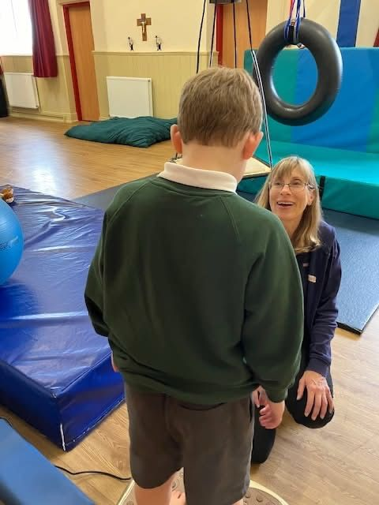
- fewer meltdowns
- improved communication through language and/ or attention development
- improved regulation of emotions and challenging behaviour
- improved ability to listen and focus

Outcome Example, 1-1 (Ayres) Sensory Integration Therapy: from biting, kicking and hitting teachers, one child thrived through a programme of 1-1 Ayres Sensory Integration Therapy. They gained confidence through intensive sessions and building connection with our therapist. They learned to regulate their behaviour and have enjoyed studying, moving into the top set of several subjects in school.

Outcome Example, 1-1 (Ayres) Sensory Integration Therapy: An adolescent who was throwing chairs/ tables at windows, peers and teachers undertook a lengthy period of therapy and regained a sense of purpose alongside mental health improvements. They are now progressing with purpose and working in a charity shop.

Board, Staff and Associates:

Our Board includes individuals with lived and clinical insight which informs our decision-making and enables us to develop clinical and financial policies that reflect the needs expressed by families.

Our developing clinical team includes, Occupational Therapists (OT) and a Speech and Language Therapist all trained or training in Sensory Integration Therapy. Specialist sports coaches lead our Cool Kids programme. Support staff include our part time, administrator, fundraiser, and finance team.

We invite you to send your queries to us https://www.sensory-people.co.uk/get-in-touch

Outcome Example, 1-1 (Ayres) Sensory Integration Therapy: A child who had challenging behaviour and couldn’t go to sleep without holding mum’s hand at age 11, has progressed well through five years of therapy. He gradually developed confidence in his ability to engage and has become more independent and made positive steps forward by joining the Cadet Corps, attending camp and has recently been accepted on to a Rugby Academy Scheme.

We achieve life changing outcomes with our long-term therapy; and feel we have fulfilled our aims when children (and their families) leave us happier and more settled in life than when they came to us.

With my thanks and best wishes,

Marion Rogerson

Chair/Founder Sensory People Charity
Tel: 07879 431371
Email: info@sensory-people.co.uk

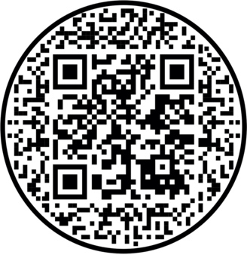
QR CODE LINK
TO OUR WEBSITE
& FUNDRAISING CAMPAIGN

